Ex1:
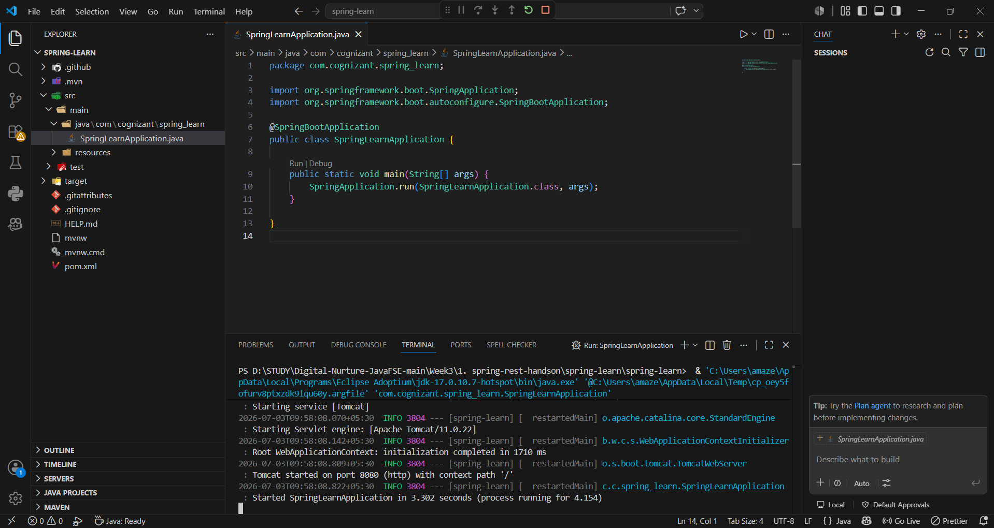
Ex2:
SpringLearnApplication.java
package com.cognizant.spring_learn;

import java.text.SimpleDateFormat;
import java.util.Date;

import org.springframework.boot.SpringApplication;
import org.springframework.boot.autoconfigure.SpringBootApplication;
import org.springframework.context.ApplicationContext;
import org.springframework.context.support.ClassPathXmlApplicationContext;

@SpringBootApplication
public class SpringLearnApplication {

public static void main(String[] args) throws Exception {
SpringApplication.run(SpringLearnApplication.class, args);

SpringLearnApplication app = new SpringLearnApplication();
app.displayDate();
}

public void displayDate() throws Exception {
ApplicationContext context = new ClassPathXmlApplicationContext("date-format.xml");
SimpleDateFormat format = context.getBean("dateFormat", SimpleDateFormat.class);
Date date = format.parse("31/12/2018");
System.out.println(date);
}
}
Date-formt.xml
<?xml version="1.0" encoding="UTF-8"?>
<beans xmlns="http://www.springframework.org/schema/beans"
xmlns:xsi="http://www.w3.org/2001/XMLSchema-instance"
xsi:schemaLocation="http://www.springframework.org/schema/beans
https://www.springframework.org/schema/beans/spring-beans.xsd">

<bean id="dateFormat" class="java.text.SimpleDateFormat">
<constructor-arg value="dd/MM/yyyy"/>
</bean>

</beans>
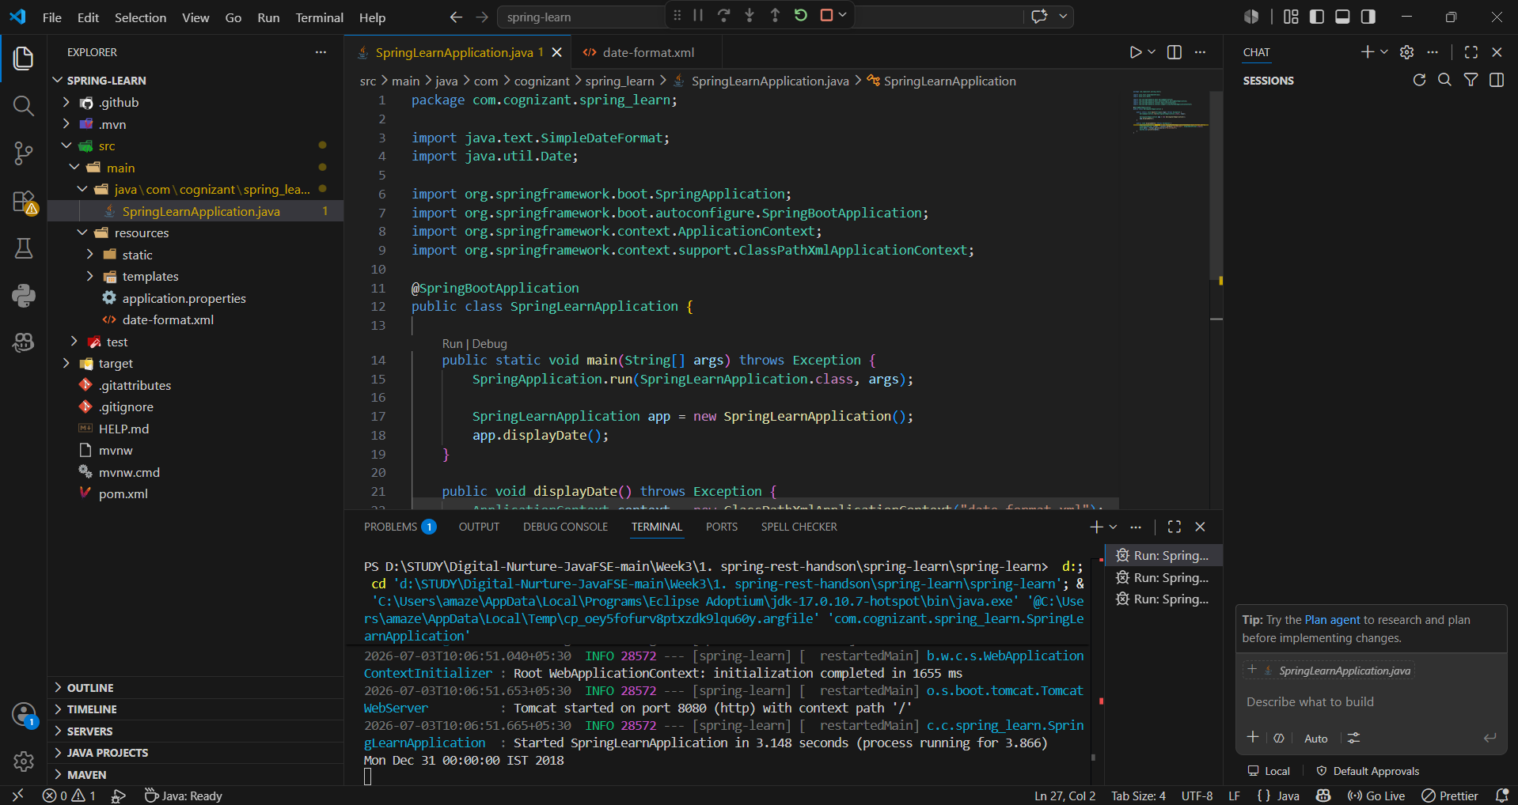
Ex3:
SpringLearnApplication.java
package com.cognizant.spring_learn;

import java.text.SimpleDateFormat;
import java.util.Date;

import org.slf4j.Logger;
import org.slf4j.LoggerFactory;

import org.springframework.boot.SpringApplication;
import org.springframework.boot.autoconfigure.SpringBootApplication;
import org.springframework.context.ApplicationContext;
import org.springframework.context.support.ClassPathXmlApplicationContext;

@SpringBootApplication
public class SpringLearnApplication {

private static final Logger LOGGER = LoggerFactory.getLogger(SpringLearnApplication.class);

public static void main(String[] args) throws Exception {
SpringApplication.run(SpringLearnApplication.class, args);

SpringLearnApplication app = new SpringLearnApplication();
app.displayDate();
}

public void displayDate() throws Exception {
LOGGER.info("START");
ApplicationContext context = new ClassPathXmlApplicationContext("date-format.xml");
SimpleDateFormat format = context.getBean("dateFormat", SimpleDateFormat.class);
Date date = format.parse("31/12/2018");
LOGGER.debug("Date : {}", date);
LOGGER.info("END");
}
}
Application.properties
logging.level.org.springframework=info
logging.level.com.cognizant.spring_learn=debug
logging.pattern.console=%d{yyMMdd}|%d{HH:mm:ss.SSS}|%-20.20thread|%5p|%-25.25logger{25}|%25M|%m%n
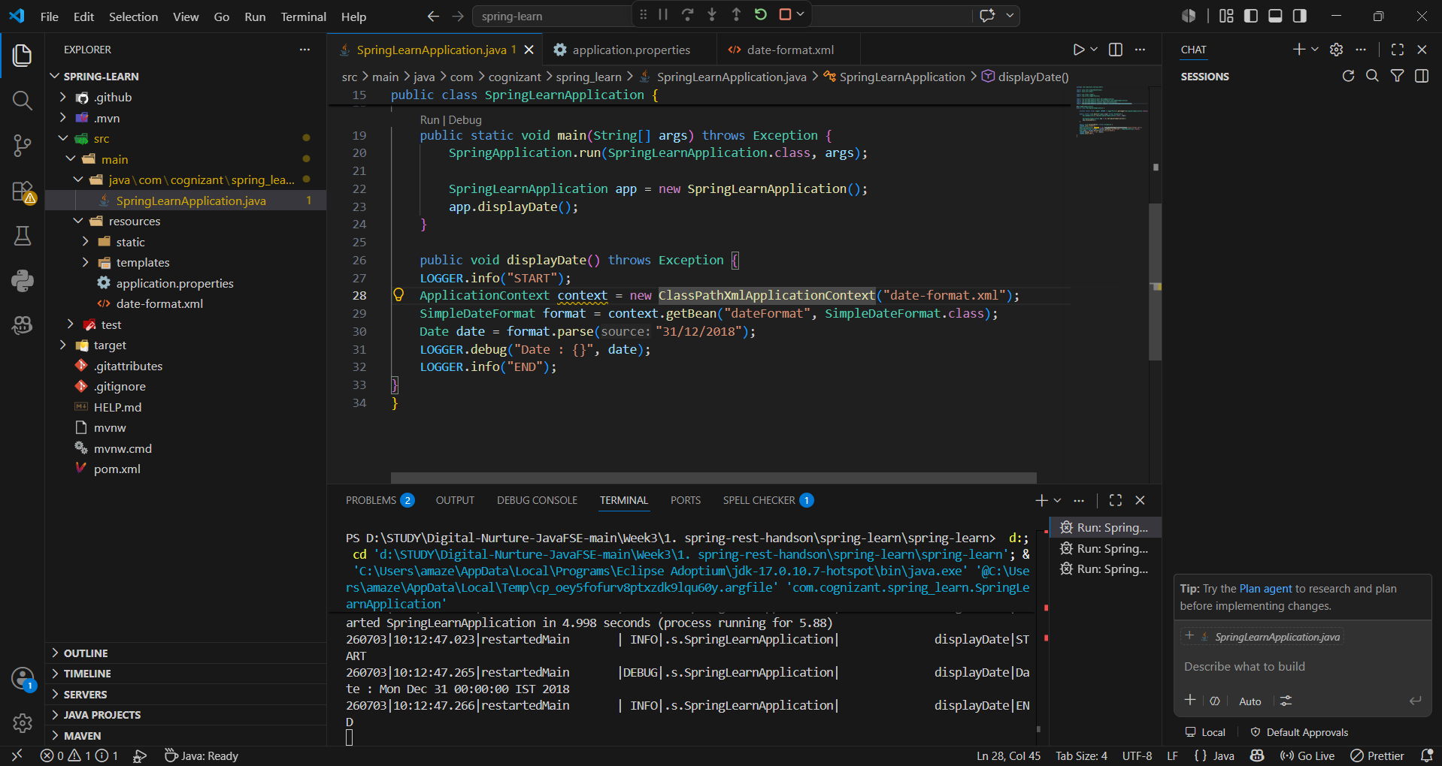
Ex4:
SpringLearnApplication.java
package com.cognizant.spring_learn;

import java.text.SimpleDateFormat;
import java.util.Date;

import org.slf4j.Logger;
import org.slf4j.LoggerFactory;
import org.springframework.boot.SpringApplication;
import org.springframework.boot.autoconfigure.SpringBootApplication;
import org.springframework.context.ApplicationContext;
import org.springframework.context.support.ClassPathXmlApplicationContext;

@SpringBootApplication
public class SpringLearnApplication {

private static final Logger LOGGER = LoggerFactory.getLogger(SpringLearnApplication.class);

public static void main(String[] args) throws Exception {
SpringApplication.run(SpringLearnApplication.class, args);

SpringLearnApplication app = new SpringLearnApplication();
app.displayDate();
app.displayCountry();
}

public void displayDate() throws Exception {
LOGGER.info("START");
ApplicationContext context = new ClassPathXmlApplicationContext("date-format.xml");
SimpleDateFormat format = context.getBean("dateFormat", SimpleDateFormat.class);
Date date = format.parse("31/12/2018");
LOGGER.debug("Date : {}", date);
LOGGER.info("END");
}

public void displayCountry() {
LOGGER.info("START");
ApplicationContext context = new ClassPathXmlApplicationContext("country.xml");
Country country = context.getBean("country", Country.class);
LOGGER.debug("Country : {}", country.toString());
LOGGER.info("END");
}
}
Country.java
package com.cognizant.spring_learn;

import org.slf4j.Logger;
import org.slf4j.LoggerFactory;

public class Country {

private static final Logger LOGGER = LoggerFactory.getLogger(Country.class);

private String code;
private String name;

public Country() {
LOGGER.debug("Inside Country Constructor.");
}

public String getCode() {
LOGGER.debug("Inside getCode()");
return code;
}

public void setCode(String code) {
LOGGER.debug("Inside setCode()");
this.code = code;
}

public String getName() {
LOGGER.debug("Inside getName()");
return name;
}

public void setName(String name) {
LOGGER.debug("Inside setName()");
this.name = name;
}

@Override
public String toString() {
return "Country [code=" + code + ", name=" + name + "]";
}
}
Country.xml
<?xml version="1.0" encoding="UTF-8"?>
<beans xmlns="http://www.springframework.org/schema/beans"
xmlns:xsi="http://www.w3.org/2001/XMLSchema-instance"
xsi:schemaLocation="http://www.springframework.org/schema/beans
https://www.springframework.org/schema/beans/spring-beans.xsd">

<bean id="country" class="com.cognizant.spring_learn.Country">
<property name="code" value="IN"/>
<property name="name" value="India"/>
</bean>

</beans>
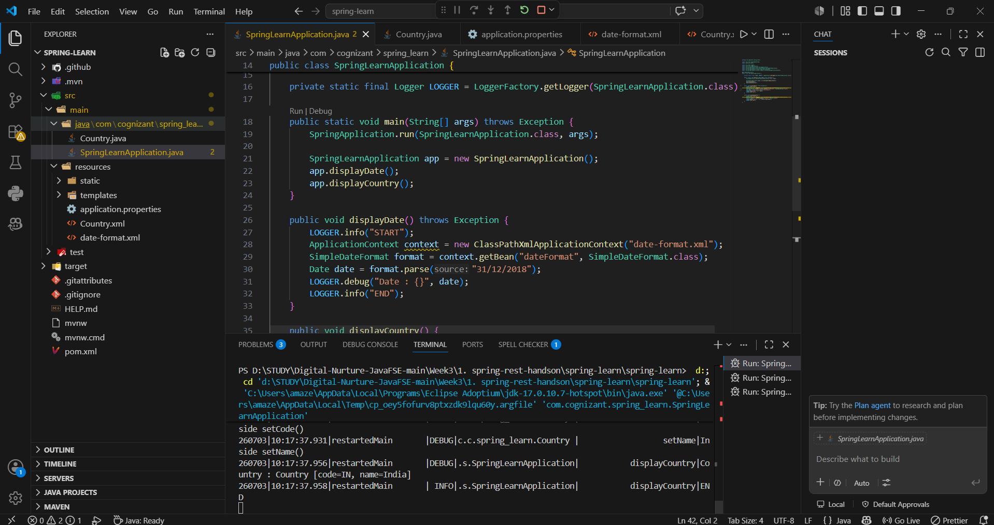

Ex5:
SpringLearnApplication.java
package com.cognizant.spring_learn;

import java.text.SimpleDateFormat;
import java.util.Date;

import org.slf4j.Logger;
import org.slf4j.LoggerFactory;
import org.springframework.boot.SpringApplication;
import org.springframework.boot.autoconfigure.SpringBootApplication;
import org.springframework.context.ApplicationContext;
import org.springframework.context.support.ClassPathXmlApplicationContext;

@SpringBootApplication
public class SpringLearnApplication {

private static final Logger LOGGER = LoggerFactory.getLogger(SpringLearnApplication.class);

public static void main(String[] args) throws Exception {
SpringApplication.run(SpringLearnApplication.class, args);

SpringLearnApplication app = new SpringLearnApplication();
app.displayDate();
app.displayCountry();
}

public void displayDate() throws Exception {
LOGGER.info("START");
ApplicationContext context = new ClassPathXmlApplicationContext("date-format.xml");
SimpleDateFormat format = context.getBean("dateFormat", SimpleDateFormat.class);
Date date = format.parse("31/12/2018");
LOGGER.debug("Date : {}", date);
LOGGER.info("END");
}

public void displayCountry() {
LOGGER.info("START");
ApplicationContext context = new ClassPathXmlApplicationContext("country.xml");
Country country = context.getBean("country", Country.class);
Country anotherCountry = context.getBean("country", Country.class);
LOGGER.debug("Country 1 : {}", country);
LOGGER.debug("Country 2 : {}", anotherCountry);
LOGGER.info("END");
}
}
Country.xml
<?xml version="1.0" encoding="UTF-8"?>
<beans xmlns="http://www.springframework.org/schema/beans"
xmlns:xsi="http://www.w3.org/2001/XMLSchema-instance"
xsi:schemaLocation="http://www.springframework.org/schema/beans
https://www.springframework.org/schema/beans/spring-beans.xsd">

<bean id="country" class="com.cognizant.spring_learn.Country" scope="prototype">
<property name="code" value="IN"/>
<property name="name" value="India"/>
</bean>

</beans>
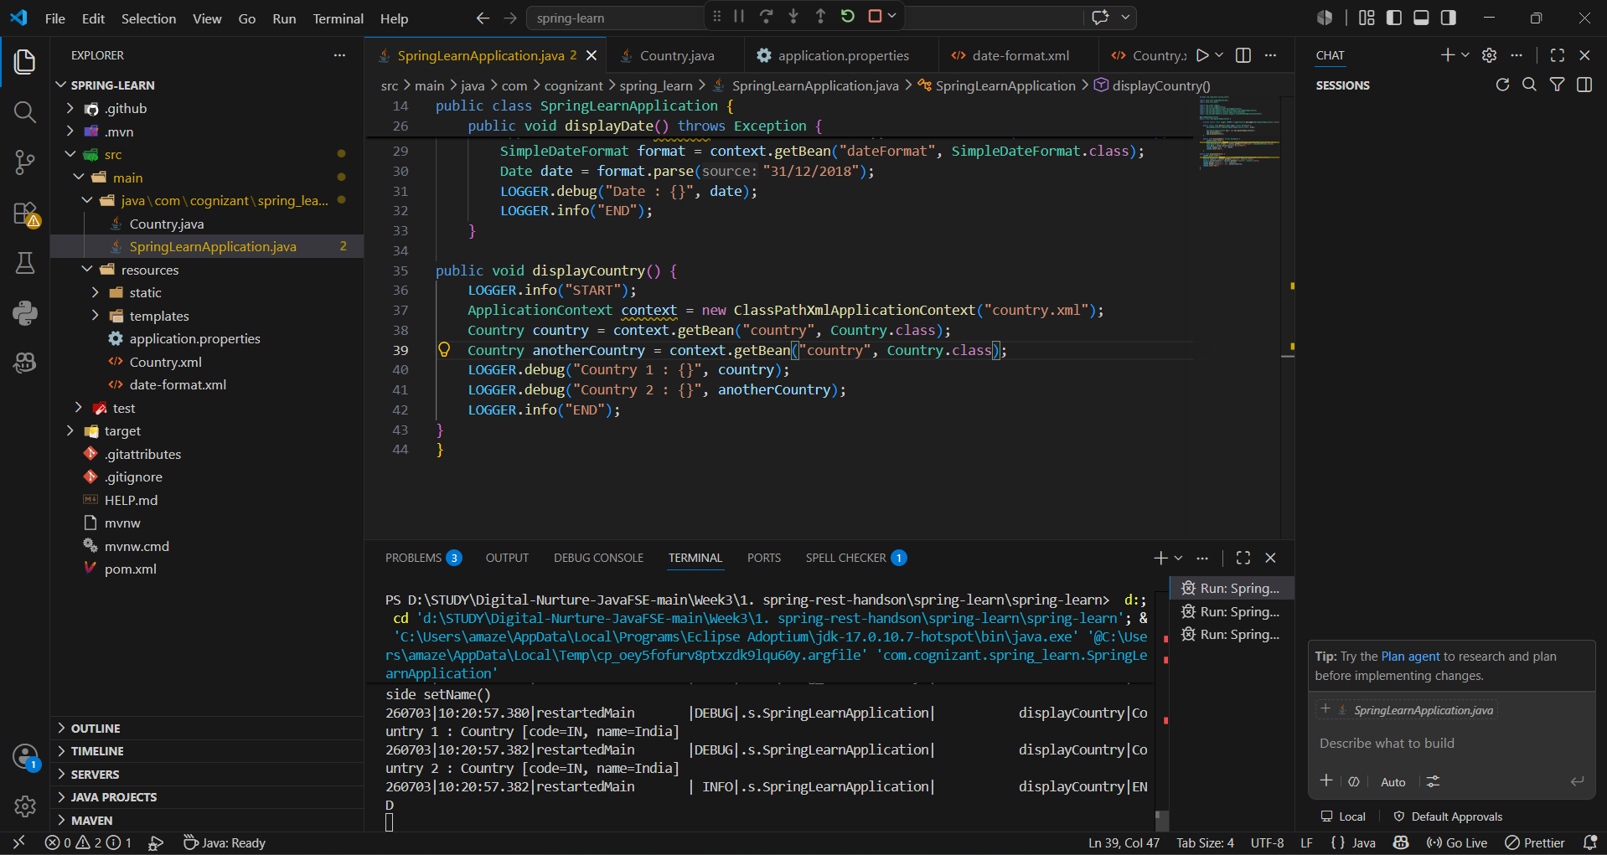
Ex6:
SpringLearnApplication.java
package com.cognizant.spring_learn;

import java.text.SimpleDateFormat;
import java.util.Date;
import java.util.List;

import org.slf4j.Logger;
import org.slf4j.LoggerFactory;
import org.springframework.boot.SpringApplication;
import org.springframework.boot.autoconfigure.SpringBootApplication;
import org.springframework.context.ApplicationContext;
import org.springframework.context.support.ClassPathXmlApplicationContext;

@SpringBootApplication
public class SpringLearnApplication {

private static final Logger LOGGER = LoggerFactory.getLogger(SpringLearnApplication.class);

public static void main(String[] args) throws Exception {
SpringApplication.run(SpringLearnApplication.class, args);

SpringLearnApplication app = new SpringLearnApplication();
app.displayDate();
app.displayCountry();
app.displayCountries();
}

public void displayDate() throws Exception {
LOGGER.info("START");
ApplicationContext context = new ClassPathXmlApplicationContext("date-format.xml");
SimpleDateFormat format = context.getBean("dateFormat", SimpleDateFormat.class);
Date date = format.parse("31/12/2018");
LOGGER.debug("Date : {}", date);
LOGGER.info("END");
}

public void displayCountry() {
LOGGER.info("START");
ApplicationContext context = new ClassPathXmlApplicationContext("country.xml");
Country country = context.getBean("in", Country.class);
LOGGER.debug("Country : {}", country);
LOGGER.info("END");
}

public void displayCountries() {
LOGGER.info("START");
ApplicationContext context = new ClassPathXmlApplicationContext("country.xml");
@SuppressWarnings("unchecked")
List<Country> countryList = context.getBean("countryList", List.class);
LOGGER.debug("Countries : {}", countryList);
LOGGER.info("END");
}
}

Country.xml
<?xml version="1.0" encoding="UTF-8"?>
<beans xmlns="http://www.springframework.org/schema/beans"
xmlns:xsi="http://www.w3.org/2001/XMLSchema-instance"
xsi:schemaLocation="http://www.springframework.org/schema/beans
https://www.springframework.org/schema/beans/spring-beans.xsd">

<bean id="in" class="com.cognizant.spring_learn.Country">
<property name="code" value="IN"/>
<property name="name" value="India"/>
</bean>

<bean id="us" class="com.cognizant.spring_learn.Country">
<property name="code" value="US"/>
<property name="name" value="United States"/>
</bean>

<bean id="de" class="com.cognizant.spring_learn.Country">
<property name="code" value="DE"/>
<property name="name" value="Germany"/>
</bean>

<bean id="jp" class="com.cognizant.spring_learn.Country">
<property name="code" value="JP"/>
<property name="name" value="Japan"/>
</bean>

<bean id="countryList" class="java.util.ArrayList">
<constructor-arg>
<list>
<ref bean="in"/>
<ref bean="us"/>
<ref bean="de"/>
<ref bean="jp"/>
</list>
</constructor-arg>
</bean>

</beans>
